Data Analysis

**01. Multiple Linear Regression, Data Preparation**

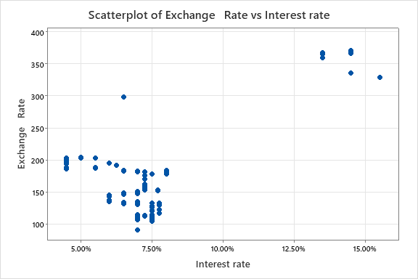

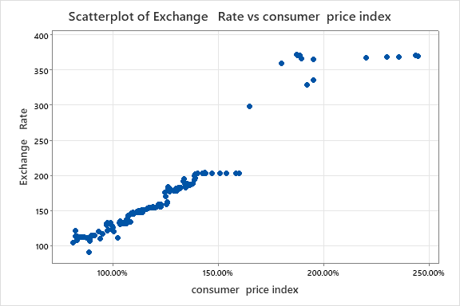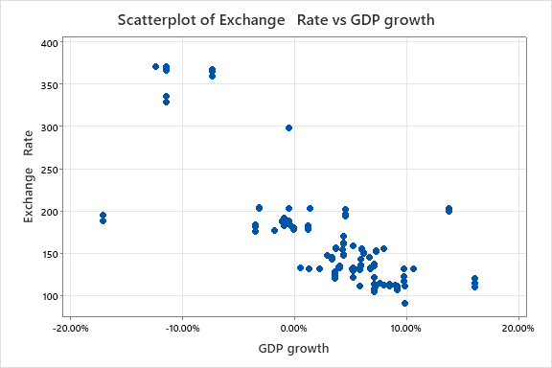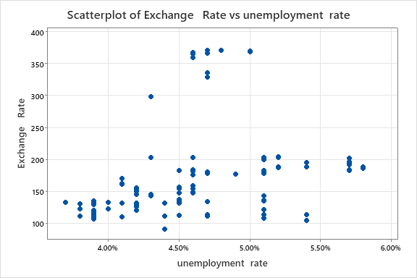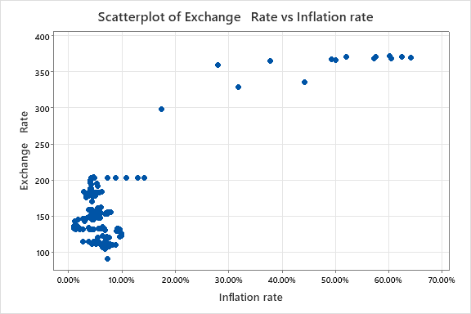

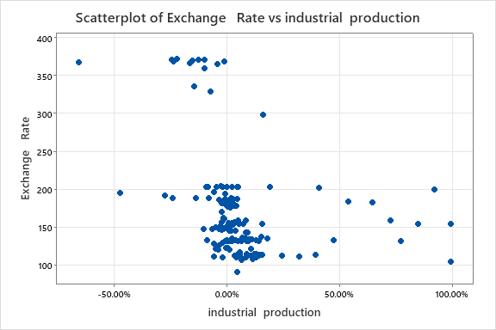

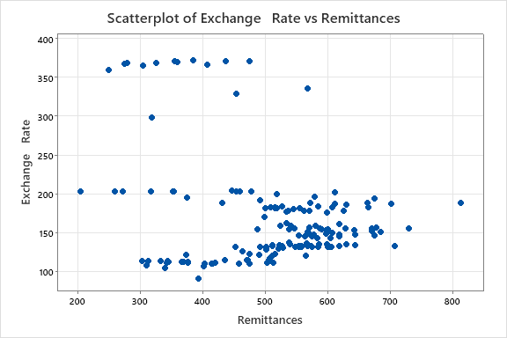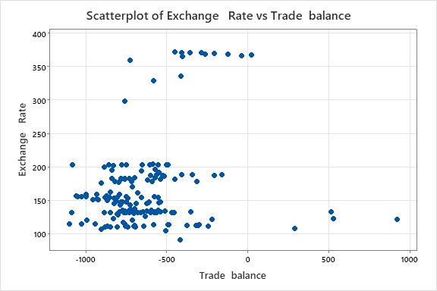

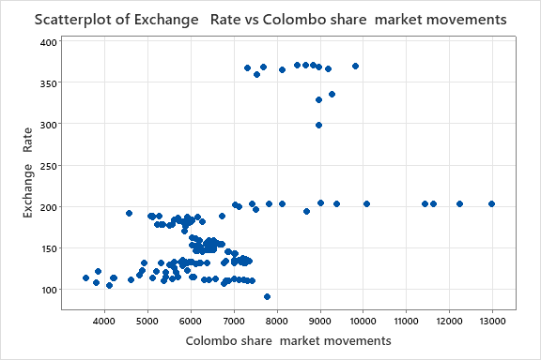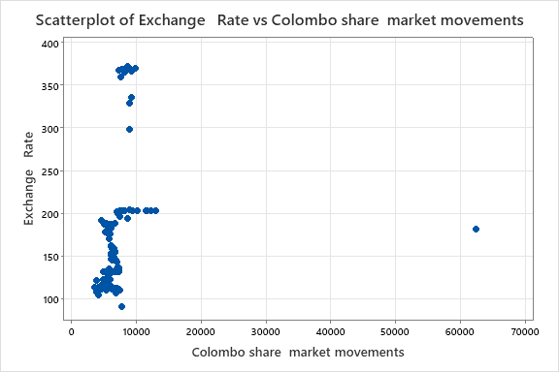

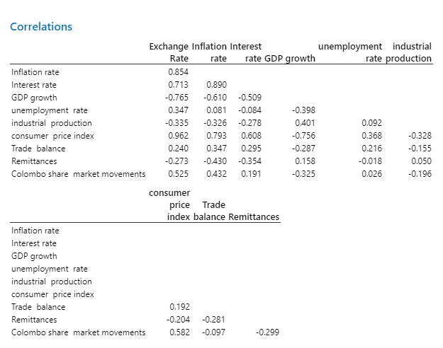

**Correlations**

|  |  |  |  |  |  |  |  |  |  |  |
| --- | --- | --- | --- | --- | --- | --- | --- | --- | --- | --- |
|  | **Exchange Rate** | | **Inflation rate** | | **Interest rate** | | **GDP growth** | | **unemployment rate** | **industrial production** |
| Inflation rate | **0.854** | |  | |  | |  | |  |  |
| Interest rate | **0.713** | | **0.890** | |  | |  | |  |  |
| GDP growth | **-0.765** | | -0.610 | | -0.509 | |  | |  |  |
| unemployment  rate | **0.347** | | **0.081** | | **-0.084** | | -0.398 | |  |  |
| industrial  production | **-0.335** | | -0.326 | | **-0.278** | | 0.401 | | **0.092** |  |
| consumer  price index | **0.962** | | **0.793** | | 0.608 | | **-0.756** | | 0.368 | -0.328 |
| Trade  balance | **0.240** | | 0.347 | | **0.295** | | **-0.287** | | **0.216** | **-0.155** |
| Remittances | **-0.273** | | -0.430 | | -0.354 | | **0.158** | | **-0.018** | **0.050** |
| Colombo share  market movements | 0.525 | | 0.432 | | **0.191** | | -0.325 | | **0.026** | **-0.196** |
|  | | **consumer price index** | | **Trade balance** | | **Remittances** | |
| Inflation rate | |  | |  | |  | |
| Interest rate | |  | |  | |  | |
| GDP growth | |  | |  | |  | |
| unemployment  rate | |  | |  | |  | |
| industrial  production | |  | |  | |  | |
| consumer  price index | |  | |  | |  | |
| Trade  balance | | **0.192** | |  | |  | |
| Remittances | | **-0.204** | | **-0.281** | |  | |
| Colombo share  market movements | | 0.582 | | **-0.097** | | **-0.299** | |

Result (IV s vs DV)

**Accepted variables -** Inflation rate / Interest rate / GDP growth / consumer price index / Colombo share market

**Rejected Variables -** unemployment rate / industrial production / Trade balance / Remittances

Result (IV s vs IV s)

**Accepted variables -** Inflation rate / unemployment rate / industrial production / consumer price index / Trade balance / Remittances / Colombo share market movements

Rejected Variables - Interest rate / GDP growth

|  |
| --- |
| Inflation rate |
| Interest rate |
| GDP growth |
| unemployment  rate |
| industrial  production |
| consumer  price index |
| Trade  balance |
| Remittances |
| Colombo share  market movements |

**2. Multiple Linear Regression, Evaluating Basic Models**

**All Possible Regression**

**Stepwise Selection of Terms**

Candidate terms: Inflation rate, Interest rate, GDP growth, consumer  price index, Colombo  
     share  market movements, unemployment  rate, industrial  production, Remittances, Trade  
     balance

|  |  |  |  |  |  |  |
| --- | --- | --- | --- | --- | --- | --- |
|  | **-----Step 1----** | | **-----Step 2----** | | **-----Step 3----** | |
|  | **Coef** | **P** | **Coef** | **P** | **Coef** | **P** |
| Constant | -69.71 |  | -82.21 |  | -122.0 |  |
| consumer  price index | 196.61 | 0.000 | 171.01 | 0.000 | 160.71 | 0.000 |
| Interest rate |  |  | 592.3 | 0.000 | 698.5 | 0.000 |
| unemployment  rate |  |  |  |  | 976 | 0.000 |
| Inflation rate |  |  |  |  |  |  |
| GDP growth |  |  |  |  |  |  |
|  |  |  |  |  |  |  |
| S |  | 18.1386 |  | 14.6399 |  | 14.0406 |
| R-sq |  | 92.53% |  | 95.16% |  | 95.58% |
| R-sq(adj) |  | 92.48% |  | 95.10% |  | 95.49% |
| Mallows’ Cp |  | 111.46 |  | 19.47 |  | 6.63 |
| AICc |  | 1376.94 |  | 1309.89 |  | 1297.70 |
| BIC |  | 1385.99 |  | 1321.90 |  | 1312.66 |
|  | **-----Step 4----** | | **-----Step 5----** | |
|  | **Coef** | **P** | **Coef** | **P** |
| Constant | -106.4 |  | -90.4 |  |
| consumer  price index | 153.54 | 0.000 | 147.46 | 0.000 |
| Interest rate | 540 | 0.000 | 501 | 0.000 |
| unemployment  rate | 993 | 0.000 | 891 | 0.001 |
| Inflation rate | 43.5 | 0.097 | 47.5 | 0.070 |
| GDP growth |  |  | -46.8 | 0.104 |
|  |  |  |  |  |
| S |  | 13.9607 |  | 13.8856 |
| R-sq |  | 95.66% |  | 95.73% |
| R-sq(adj) |  | 95.54% |  | 95.59% |
| Mallows’ Cp |  | 5.83 |  | 5.17 |
| AICc |  | 1297.02 |  | 1296.46 |
| BIC |  | 1314.88 |  | 1317.20 |

*α to enter = 0.15, α to remove = 0.15*

**Regression Equation**

|  |  |  |
| --- | --- | --- |
| Exchange   Rate | = | -90.4 + 47.5 Inflation rate + 501 Interest rate - 46.8 GDP growth + 147.46 consumer  price index + 891 unemployment  rate |

**Coefficients**

|  |  |  |  |  |  |
| --- | --- | --- | --- | --- | --- |
| **Term** | **Coef** | **SE Coef** | **T-Value** | **P-Value** | **VIF** |
| Constant | -90.4 | 17.6 | -5.15 | 0.000 |  |
| Inflation rate | 47.5 | 26.1 | 1.82 | 0.070 | 9.46 |
| Interest rate | 501 | 118 | 4.24 | 0.000 | 6.00 |
| GDP growth | -46.8 | 28.6 | -1.63 | 0.104 | 2.71 |
| consumer  price index | 147.46 | 7.61 | 19.39 | 0.000 | 4.96 |
| unemployment  rate | 891 | 261 | 3.42 | 0.001 | 1.48 |

**Model Summary**

|  |  |  |  |
| --- | --- | --- | --- |
| **S** | **R-sq** | **R-sq(adj)** | **R-sq(pred)** |
| 13.8856 | 95.73% | 95.59% | 94.81% |

**Analysis of Variance**

|  |  |  |  |  |  |
| --- | --- | --- | --- | --- | --- |
| **Source** | **DF** | **Adj SS** | **Adj MS** | **F-Value** | **P-Value** |
| Regression | 5 | 661592 | 132318 | 686.27 | 0.000 |
| Inflation rate | 1 | 641 | 641 | 3.33 | 0.070 |
| Interest rate | 1 | 3461 | 3461 | 17.95 | 0.000 |
| GDP growth | 1 | 515 | 515 | 2.67 | 0.104 |
| consumer  price index | 1 | 72467 | 72467 | 375.85 | 0.000 |
| unemployment  rate | 1 | 2253 | 2253 | 11.68 | 0.001 |
| Error | 153 | 29500 | 193 |  |  |
| Total | 158 | 691092 |  |  |  |

**Fits and Diagnostics for Unusual Observations**

|  |  |  |  |  |  |  |
| --- | --- | --- | --- | --- | --- | --- |
| **Obs** | **Exchange Rate** | **Fit** | **Resid** | **Std Resid** |  |  |
| 125 | 188.62 | 193.04 | -4.42 | -0.35 |  | X |
| 126 | 188.51 | 194.62 | -6.11 | -0.48 |  | X |
| 147 | 299.00 | 232.08 | 66.92 | 4.97 | R |  |
| 148 | 360.00 | 300.63 | 59.37 | 4.55 | R | X |
| 149 | 365.75 | 327.41 | 38.34 | 2.86 | R |  |
| 151 | 368.41 | 398.68 | -30.27 | -2.30 | R |  |
| 152 | 368.90 | 408.61 | -39.71 | -3.04 | R | X |
| 153 | 369.91 | 423.44 | -53.53 | -4.15 | R | X |
| 154 | 371.21 | 419.95 | -48.74 | -3.76 | R | X |
| 155 | 371.72 | 335.24 | 36.48 | 2.85 | R | X |
| 156 | 371.61 | 334.75 | 36.86 | 2.84 | R | X |
| 157 | 371.39 | 332.29 | 39.10 | 2.95 | R |  |
| 158 | 366.92 | 332.72 | 34.20 | 2.57 | R |  |
| 160 | 328.75 | 333.15 | -4.40 | -0.36 |  | X |

*R  Large residual  
X  Unusual X*

**Backward Elimination**

**Backward Elimination of Terms**

Candidate terms: Inflation rate, Interest rate, GDP growth, consumer  price index, Colombo  
     share  market movements, unemployment  rate, industrial  production, Remittances, Trade  
     balance

|  |  |  |  |  |  |  |  |  |  |  |
| --- | --- | --- | --- | --- | --- | --- | --- | --- | --- | --- |
|  | **------Step 1-----** | | | | **-----Step 2-----** | | | | **-----Step 3-----** | |
|  | **Coef** | | **P** | | **Coef** | | **P** | | **Coef** | **P** |
| Constant | -101.5 | |  | | -102.0 | |  | | -99.6 |  |
| Inflation rate | 34.0 | | 0.261 | | 28.3 | | 0.330 | | 30.2 | 0.295 |
| Interest rate | 575 | | 0.000 | | 589 | | 0.000 | | 580 | 0.000 |
| GDP growth | -50.3 | | 0.099 | | -46.8 | | 0.119 | | -51.7 | 0.075 |
| consumer  price index | 142.93 | | 0.000 | | 144.03 | | 0.000 | | 144.31 | 0.000 |
| Colombo share  market movements | 0.00109 | | 0.368 | | 0.00129 | | 0.270 | | 0.00127 | 0.278 |
| unemployment  rate | 1086 | | 0.001 | | 1050 | | 0.001 | | 995 | 0.001 |
| industrial  production | -4.35 | | 0.476 | | -3.82 | | 0.528 | |  |  |
| Remittances | -0.0104 | | 0.399 | | -0.0088 | | 0.468 | | -0.0083 | 0.493 |
| Trade  balance | -0.00319 | | 0.494 | |  | |  | |  |  |
|  |  | |  | |  | |  | |  |  |
| S |  | | 13.9232 | |  | | 13.8986 | |  | 13.8710 |
| R-sq |  | | 95.82% | |  | | 95.81% | |  | 95.80% |
| R-sq(adj) |  | | 95.57% | |  | | 95.58% | |  | 95.60% |
| Mallows’ Cp |  | | 10.00 | |  | | 8.47 | |  | 6.87 |
| AICc |  | | 1302.16 | |  | | 1300.35 | |  | 1298.50 |
| BIC |  | | 1334.12 | |  | | 1329.56 | |  | 1324.91 |
|  | **-----Step 4-----** | | | **-----Step 5-----** | | | |
|  | **Coef** | **P** | | **Coef** | | **P** | |
| Constant | -105.1 |  | | -122.5 | |  | |
| Inflation rate | 36.5 | 0.182 | |  | |  | |
| Interest rate | 581 | 0.000 | | 727.4 | | 0.000 | |
| GDP growth | -51.2 | 0.077 | | -49.0 | | 0.090 | |
| consumer  price index | 142.04 | 0.000 | | 146.34 | | 0.000 | |
| Colombo share  market movements | 0.00151 | 0.175 | | 0.00195 | | 0.068 | |
| unemployment  rate | 1035 | 0.000 | | 1073 | | 0.000 | |
| industrial  production |  |  | |  | |  | |
| Remittances |  |  | |  | |  | |
| Trade  balance |  |  | |  | |  | |
|  |  |  | |  | |  | |
| S |  | 13.8469 | |  | | 13.8828 | |
| R-sq |  | 95.78% | |  | | 95.73% | |
| R-sq(adj) |  | 95.62% | |  | | 95.59% | |
| Mallows’ Cp |  | 5.34 | |  | | 5.11 | |
| AICc |  | 1296.75 | |  | | 1296.40 | |
| BIC |  | 1320.34 | |  | | 1317.14 | |

*α to remove = 0.1*

**Regression Equation**

|  |  |  |
| --- | --- | --- |
| Exchange   Rate | = | -122.5 + 727.4 Interest rate - 49.0 GDP growth + 146.34 consumer  price index + 0.00195 Colombo share  market movements + 1073 unemployment  rate |

**Coefficients**

|  |  |  |  |  |  |
| --- | --- | --- | --- | --- | --- |
| **Term** | **Coef** | **SE Coef** | **T-Value** | **P-Value** | **VIF** |
| Constant | -122.5 | 16.1 | -7.61 | 0.000 |  |
| Interest rate | 727.4 | 73.9 | 9.84 | 0.000 | 2.35 |
| GDP growth | -49.0 | 28.8 | -1.70 | 0.090 | 2.73 |
| consumer  price index | 146.34 | 7.96 | 18.38 | 0.000 | 5.44 |
| Colombo share  market movements | 0.00195 | 0.00106 | 1.84 | 0.068 | 1.96 |
| unemployment  rate | 1073 | 280 | 3.83 | 0.000 | 1.71 |

**Model Summary**

|  |  |  |  |
| --- | --- | --- | --- |
| **S** | **R-sq** | **R-sq(adj)** | **R-sq(pred)** |
| 13.8828 | 95.73% | 95.59% | 95.01% |

**Analysis of Variance**

|  |  |  |  |  |  |
| --- | --- | --- | --- | --- | --- |
| **Source** | **DF** | **Adj SS** | **Adj MS** | **F-Value** | **P-Value** |
| Regression | 5 | 661604 | 132321 | 686.55 | 0.000 |
| Interest rate | 1 | 18654 | 18654 | 96.79 | 0.000 |
| GDP growth | 1 | 560 | 560 | 2.91 | 0.090 |
| consumer  price index | 1 | 65114 | 65114 | 337.85 | 0.000 |
| Colombo share  market movements | 1 | 653 | 653 | 3.39 | 0.068 |
| unemployment  rate | 1 | 2829 | 2829 | 14.68 | 0.000 |
| Error | 153 | 29488 | 193 |  |  |
| Total | 158 | 691092 |  |  |  |

**Fits and Diagnostics for Unusual Observations**

|  |  |  |  |  |  |  |
| --- | --- | --- | --- | --- | --- | --- |
| **Obs** | **Exchange Rate** | **Fit** | **Resid** | **Std Resid** |  |  |
| 125 | 188.62 | 190.25 | -1.63 | -0.13 |  | X |
| 126 | 188.51 | 191.78 | -3.27 | -0.26 |  | X |
| 144 | 203.00 | 211.82 | -8.82 | -0.68 |  | X |
| 145 | 203.00 | 221.03 | -18.03 | -1.41 |  | X |
| 147 | 299.00 | 230.01 | 68.98 | 5.11 | R |  |
| 148 | 360.00 | 307.15 | 52.85 | 3.91 | R |  |
| 149 | 365.75 | 330.22 | 35.53 | 2.64 | R |  |
| 152 | 368.90 | 404.86 | -35.96 | -2.73 | R |  |
| 153 | 369.91 | 419.54 | -49.63 | -3.80 | R | X |
| 154 | 371.21 | 414.26 | -43.05 | -3.31 | R | X |
| 155 | 371.72 | 331.30 | 40.42 | 3.05 | R |  |
| 156 | 371.61 | 331.65 | 39.96 | 3.01 | R |  |
| 157 | 371.39 | 332.35 | 39.04 | 2.94 | R |  |
| 158 | 366.92 | 334.34 | 32.58 | 2.46 | R |  |

*R  Large residual  
X  Unusual X*

**Forward Selection**

**Forward Selection of Terms**

Candidate terms: Inflation rate, Interest rate, GDP growth, consumer  price index, Colombo  
     share  market movements, unemployment  rate, industrial  production, Remittances, Trade  
     balance

|  |  |  |  |  |  |  |  |
| --- | --- | --- | --- | --- | --- | --- | --- |
|  | **-----Step 1----** | | **-----Step 2----** | | **-----Step 3----** | | |
|  | **Coef** | **P** | **Coef** | **P** | **Coef** | **P** | |
| Constant | -69.71 |  | -82.21 |  | -122.0 |  | |
| consumer  price index | 196.61 | 0.000 | 171.01 | 0.000 | 160.71 | 0.000 | |
| Interest rate |  |  | 592.3 | 0.000 | 698.5 | 0.000 | |
| unemployment  rate |  |  |  |  | 976 | 0.000 | |
| Inflation rate |  |  |  |  |  |  | |
| GDP growth |  |  |  |  |  |  | |
| Colombo share  market movements |  |  |  |  |  |  | |
|  |  |  |  |  |  |  | |
| S |  | 18.1386 |  | 14.6399 |  | 14.0406 | |
| R-sq |  | 92.53% |  | 95.16% |  | 95.58% | |
| R-sq(adj) |  | 92.48% |  | 95.10% |  | 95.49% | |
| Mallows’ Cp |  | 111.46 |  | 19.47 |  | 6.63 | |
| AICc |  | 1376.94 |  | 1309.89 |  | 1297.70 | |
| BIC |  | 1385.99 |  | 1321.90 |  | 1312.66 | |
|  | **-----Step 4----** | | **-----Step 5----** | | **-----Step 6-----** | | | |
|  | **Coef** | **P** | **Coef** | **P** | **Coef** | | **P** | |
| Constant | -106.4 |  | -90.4 |  | -105.1 | |  | |
| consumer  price index | 153.54 | 0.000 | 147.46 | 0.000 | 142.04 | | 0.000 | |
| Interest rate | 540 | 0.000 | 501 | 0.000 | 581 | | 0.000 | |
| unemployment  rate | 993 | 0.000 | 891 | 0.001 | 1035 | | 0.000 | |
| Inflation rate | 43.5 | 0.097 | 47.5 | 0.070 | 36.5 | | 0.182 | |
| GDP growth |  |  | -46.8 | 0.104 | -51.2 | | 0.077 | |
| Colombo share  market movements |  |  |  |  | 0.00151 | | 0.175 | |
|  |  |  |  |  |  | |  | |
| S |  | 13.9607 |  | 13.8856 |  | | 13.8469 | |
| R-sq |  | 95.66% |  | 95.73% |  | | 95.78% | |
| R-sq(adj) |  | 95.54% |  | 95.59% |  | | 95.62% | |
| Mallows’ Cp |  | 5.83 |  | 5.17 |  | | 5.34 | |
| AICc |  | 1297.02 |  | 1296.46 |  | | 1296.75 | |
| BIC |  | 1314.88 |  | 1317.20 |  | | 1320.34 | |

*α to enter = 0.25*

**Regression Equation**

|  |  |  |
| --- | --- | --- |
| Exchange   Rate | = | -105.1 + 36.5 Inflation rate + 581 Interest rate - 51.2 GDP growth + 142.04 consumer  price index + 0.00151 Colombo share  market movements + 1035 unemployment  rate |

**Coefficients**

|  |  |  |  |  |  |
| --- | --- | --- | --- | --- | --- |
| **Term** | **Coef** | **SE Coef** | **T-Value** | **P-Value** | **VIF** |
| Constant | -105.1 | 20.6 | -5.10 | 0.000 |  |
| Inflation rate | 36.5 | 27.2 | 1.34 | 0.182 | 10.38 |
| Interest rate | 581 | 132 | 4.41 | 0.000 | 7.51 |
| GDP growth | -51.2 | 28.7 | -1.78 | 0.077 | 2.74 |
| consumer  price index | 142.04 | 8.56 | 16.59 | 0.000 | 6.33 |
| Colombo share  market movements | 0.00151 | 0.00111 | 1.36 | 0.175 | 2.16 |
| unemployment  rate | 1035 | 281 | 3.69 | 0.000 | 1.73 |

**Model Summary**

|  |  |  |  |
| --- | --- | --- | --- |
| **S** | **R-sq** | **R-sq(adj)** | **R-sq(pred)** |
| 13.8469 | 95.78% | 95.62% | 94.80% |

**Analysis of Variance**

|  |  |  |  |  |  |
| --- | --- | --- | --- | --- | --- |
| **Source** | **DF** | **Adj SS** | **Adj MS** | **F-Value** | **P-Value** |
| Regression | 6 | 661948 | 110325 | 575.39 | 0.000 |
| Inflation rate | 1 | 344 | 344 | 1.79 | 0.182 |
| Interest rate | 1 | 3727 | 3727 | 19.44 | 0.000 |
| GDP growth | 1 | 609 | 609 | 3.18 | 0.077 |
| consumer  price index | 1 | 52751 | 52751 | 275.12 | 0.000 |
| Colombo share  market movements | 1 | 356 | 356 | 1.86 | 0.175 |
| unemployment  rate | 1 | 2608 | 2608 | 13.60 | 0.000 |
| Error | 152 | 29144 | 192 |  |  |
| Total | 158 | 691092 |  |  |  |

**Fits and Diagnostics for Unusual Observations**

|  |  |  |  |  |  |  |
| --- | --- | --- | --- | --- | --- | --- |
| **Obs** | **Exchange Rate** | **Fit** | **Resid** | **Std Resid** |  |  |
| 125 | 188.62 | 191.28 | -2.66 | -0.21 |  | X |
| 126 | 188.51 | 192.75 | -4.24 | -0.34 |  | X |
| 145 | 203.00 | 220.86 | -17.86 | -1.40 |  | X |
| 147 | 299.00 | 231.47 | 67.52 | 5.03 | R |  |
| 148 | 360.00 | 302.24 | 57.76 | 4.45 | R |  |
| 149 | 365.75 | 327.99 | 37.76 | 2.83 | R |  |
| 151 | 368.41 | 396.13 | -27.72 | -2.13 | R |  |
| 152 | 368.90 | 407.31 | -38.41 | -2.96 | R |  |
| 153 | 369.91 | 422.54 | -52.63 | -4.10 | R | X |
| 154 | 371.21 | 417.29 | -46.08 | -3.60 | R | X |
| 155 | 371.72 | 335.92 | 35.80 | 2.81 | R | X |
| 156 | 371.61 | 335.39 | 36.22 | 2.80 | R |  |
| 157 | 371.39 | 333.89 | 37.50 | 2.84 | R |  |
| 158 | 366.92 | 334.99 | 31.93 | 2.42 | R |  |
| 160 | 328.75 | 337.76 | -9.00 | -0.76 |  | X |

*R  Large residual  
X  Unusual X*